Emerging Technologies

Group 5

| Priyesh Pandya | Hasan Ahmad | Ermin Zeherovic |

| Punith Agraharavalagerahalli Jayaramu | Jennifer Sager |

# Table of Contents

Updated Proposal 3

Flowcharts 5

Project Outcomes 7

Conclusion 8

# Updated Proposal

Abstract: An e-commerce B2C application using flask app. Emerging Technologies is an e-commerce B2C application which will provide end customers with the latest and greatest technology products to purchase with Cybersecurity risk ratings on whether the products are vulnerable or not.

Objectives:

1. Display Technology products - Completed
2. Feature to filter the products based on the area of interest - Completed
3. Indicators for Cybersecurity Risk Ratings - Completed
4. Display user profiles - Completed
5. Display Shopping Cart - Completed
6. Feature to add more than one quantity of the same product - Completed
7. Feature to remove product - Completed
8. Feature to show the prices - Completed
9. Feature to integrate different payment types - Completed
10. Feature to process the order - Completed
11. Feature to download, print and email receipts - Completed

Schedule:

1. Proposal – July 12, 2023 - Completed
2. Flowcharts – July 14, 2023 – July 19, 2023 - Completed
3. Development of the project – July 20, 2023 – July 25, 2023 - Completed
4. Creation of the Report – July 26, 2023 – July 28, 2023 – In Progress
5. Creation of the Application demo – July 26, 2023 – July 28, 2023 – Not Started
6. Creation of the PowerPoint – July 29, 2023 – July 31, 2023 – Not Started
7. Rehearsal of the Presentation – July 31, 2023 – August 2nd, 2023 – Not Started
8. Submit Report – August 1st, 2023 – Not Started
9. Submit Final PowerPoint – August 2nd, 2023 – Not Started

Meetings:

Every other day meeting at 2-3pm until August 2nd, 2023

Tools:

· Docker - Used

· Docker Hub - Used

· PyCharm - Used

· GitHub - Used

· Lucido Flowchart / Visio - Used

· Trello - Used

· Discord - Used

· MS Teams - Used

# Flowcharts

Program Walkthrough

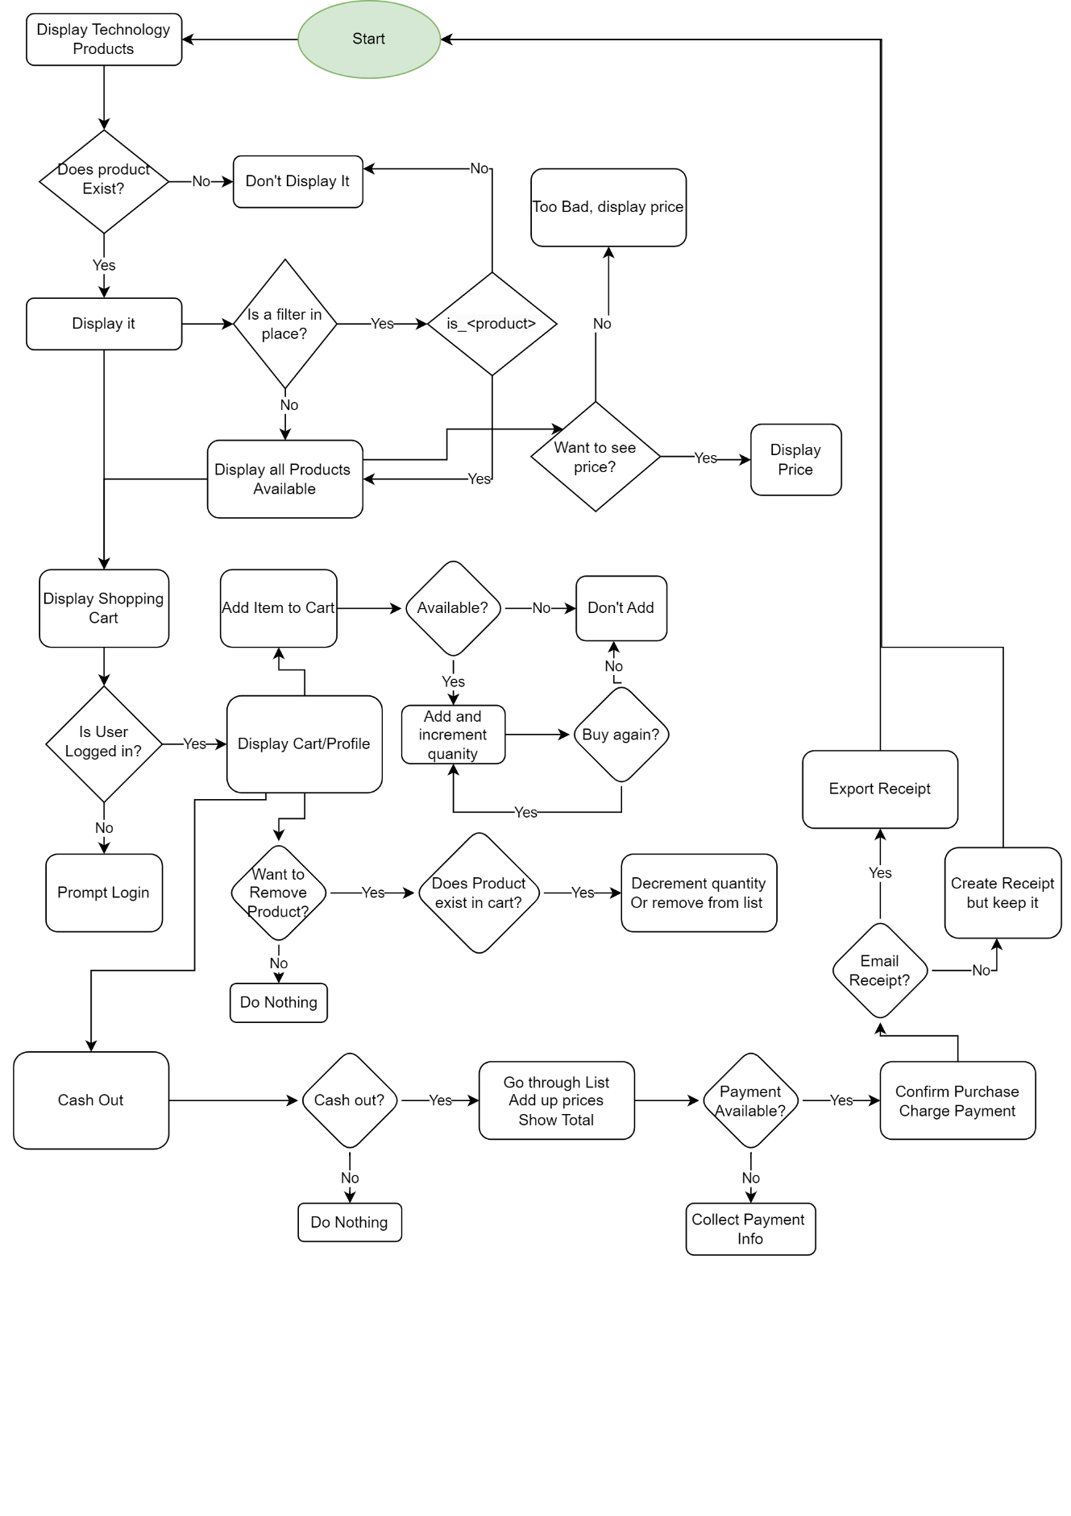

Architecture

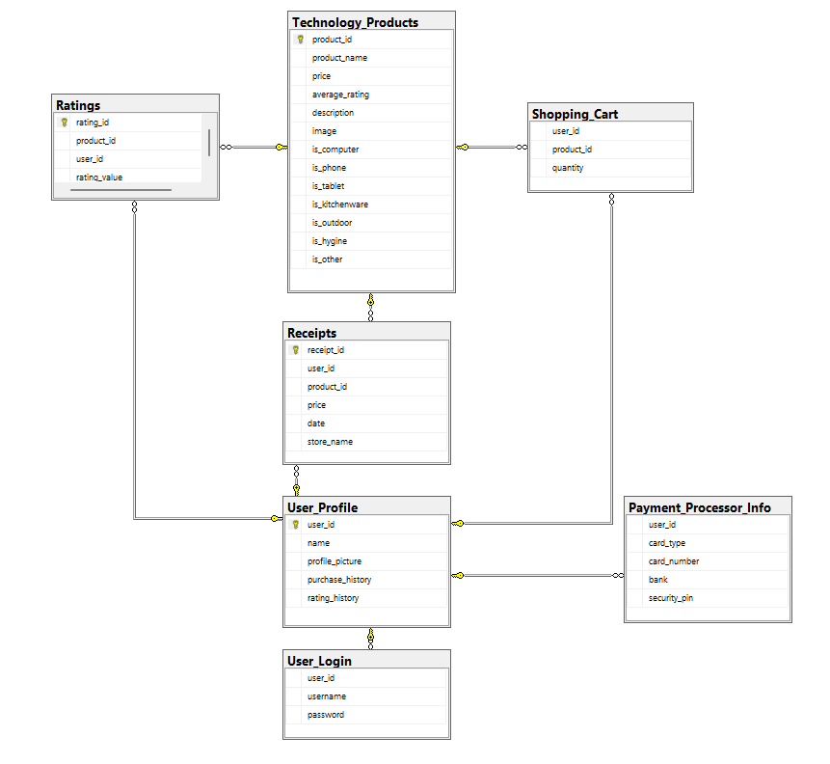

# 

# Project Outcomes

We wanted to apply our learnings that we learned from the CSC 5991 – Scalable Microservices class and create an e-commerce B2C application as part of the final group project. In our e-commerce B2C application, we set objectives that were realistic for us as a group that we could achieve to create a proof of concept to apply Human Centered Design Thinking which would help validate our idea.

One of the reasons behind using Human Centered Design Thinking was to pair it with agile process which is to develop an application quickly and fail fast if our idea doesn’t work. This approach is standard norm in the I.T. industry where technology is rapidly changing, often lacks resources, enables innovative ideas, improves the internal process, etc.

With just about ~2 weeks, our proof of concept turned into reality with an application that enabled us to develop using new technologies that is efficient, easy to manage and creating transparency throughout the process of DEVOPS.

List of Detailed Outcomes are listed below:

* + Used agile methodology.
  + Used Docker to create Container to build our 10 microservices:
    1. Home Page
    2. Display Technology Products
    3. Cybersecurity Risk Ratings
    4. Display User Profile
    5. Display Shopping Cart
    6. Management of Products
    7. Display and Track Product Prices
    8. Management of Payment
    9. To Process Orders
    10. To download, print, email receipts
  + Used GitHub to save and track the code.
  + Used Trello to keep track of the project tasks.
  + Used Microservice Design Pattern.
  + Used Kubernetes to create PODs and container registry.
  + Used Jenkins to build pipelines.
  + Used Postman to test each of the endpoints.

# Screenshot of the Outcome

Screenshots of the outcome which will showcase our application running in a container and calling each microservices via Postman.

**Screenshot of Images in Docker Hub:**

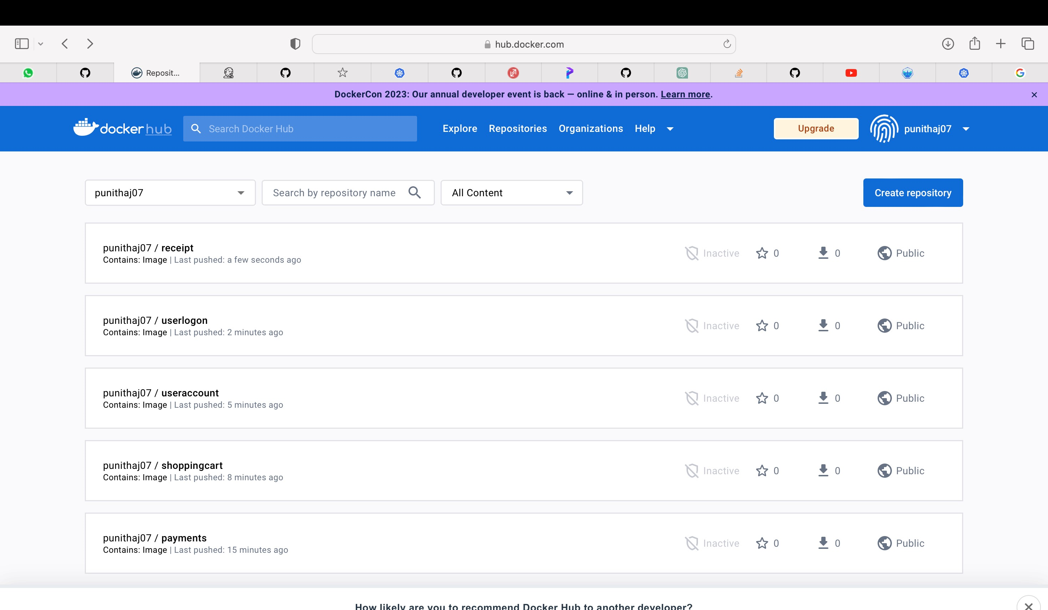

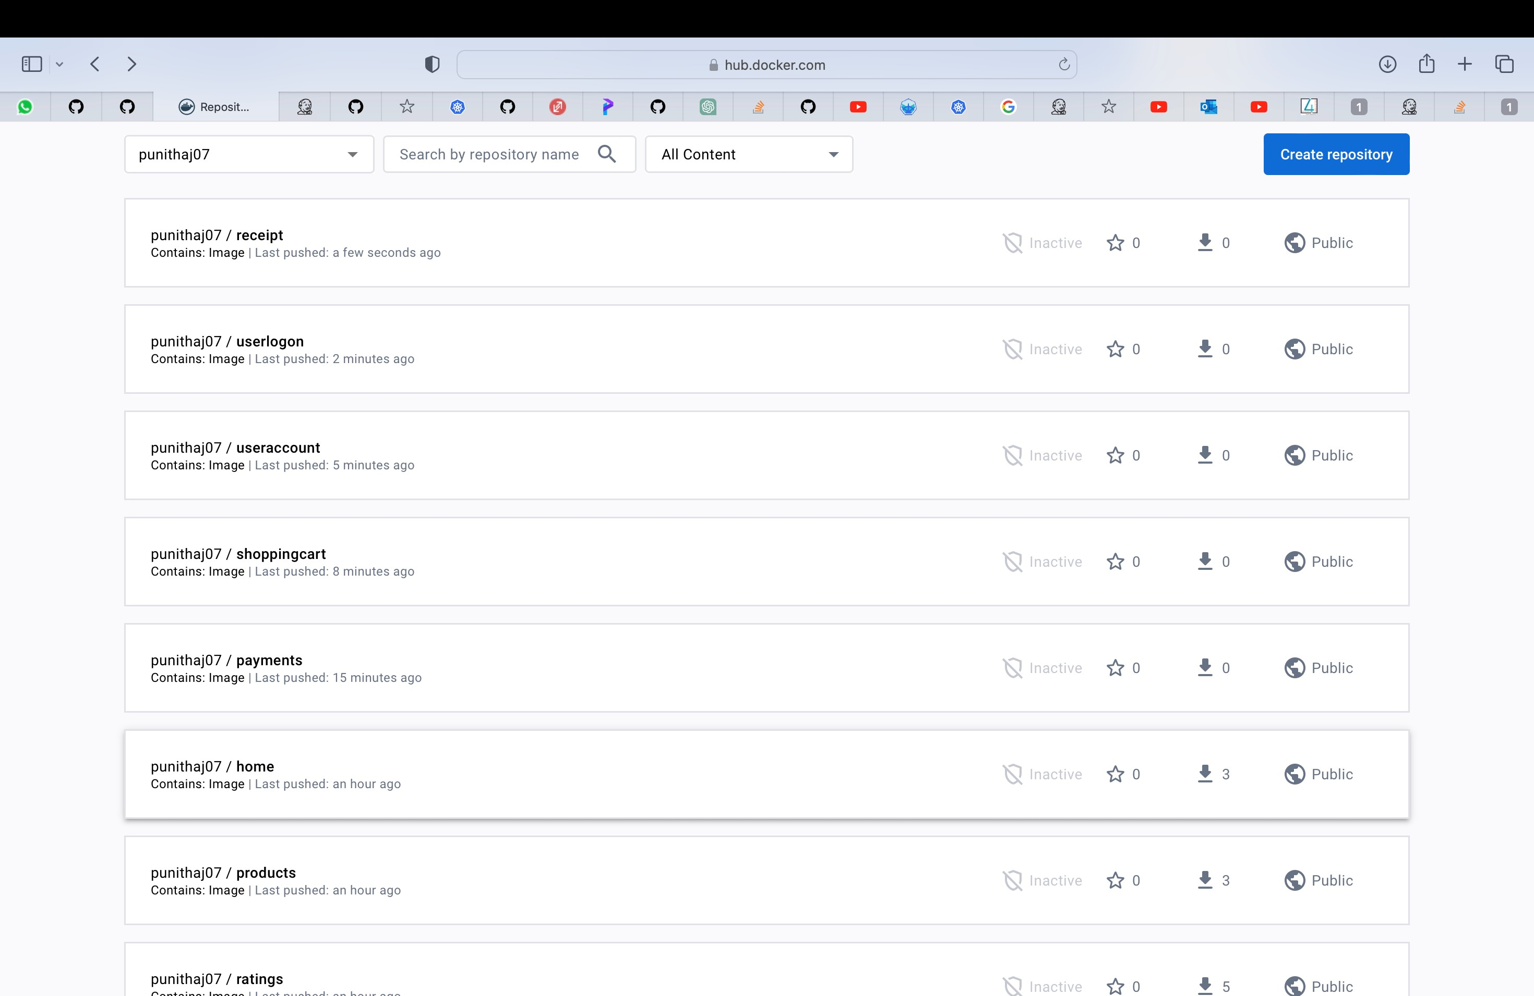

**Screenshot of Pods in Kubernetes:**

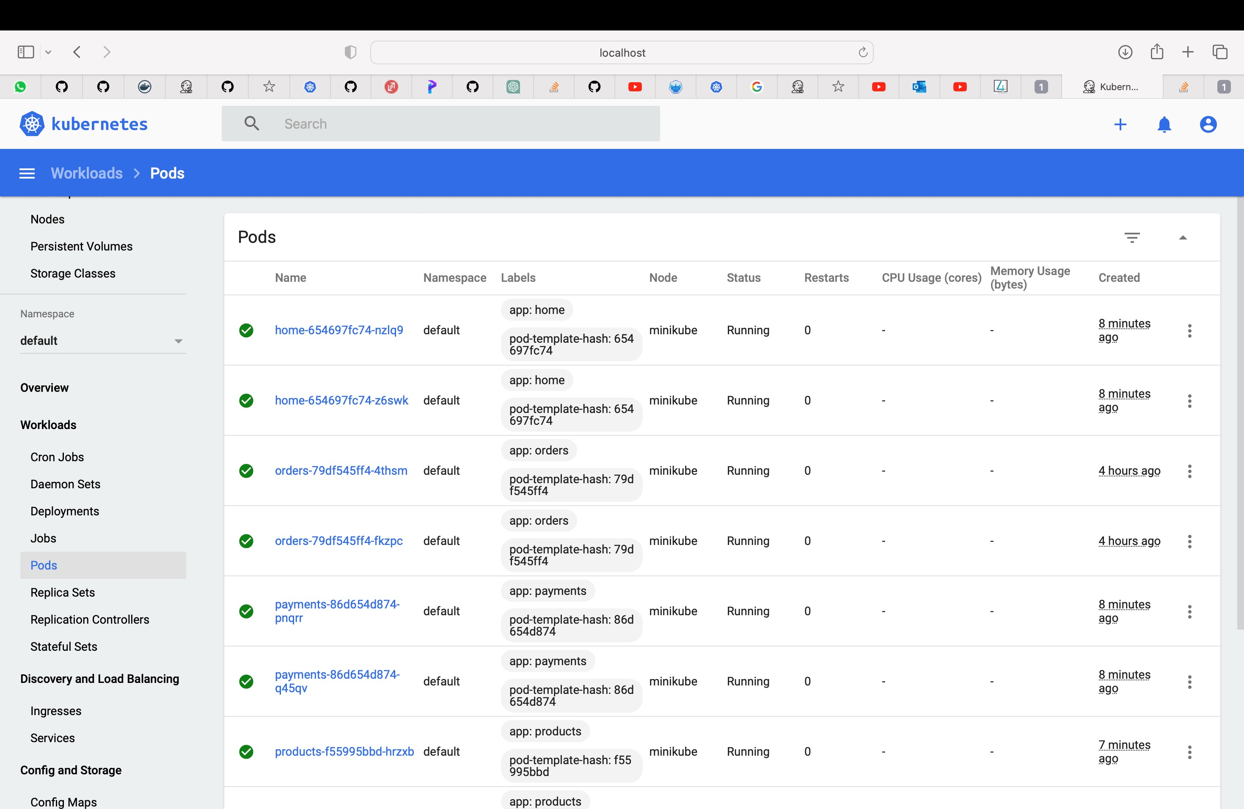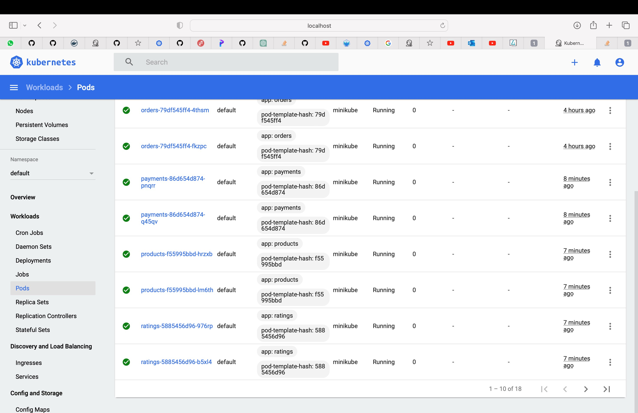

**Screenshot of Containers running in Docker:**

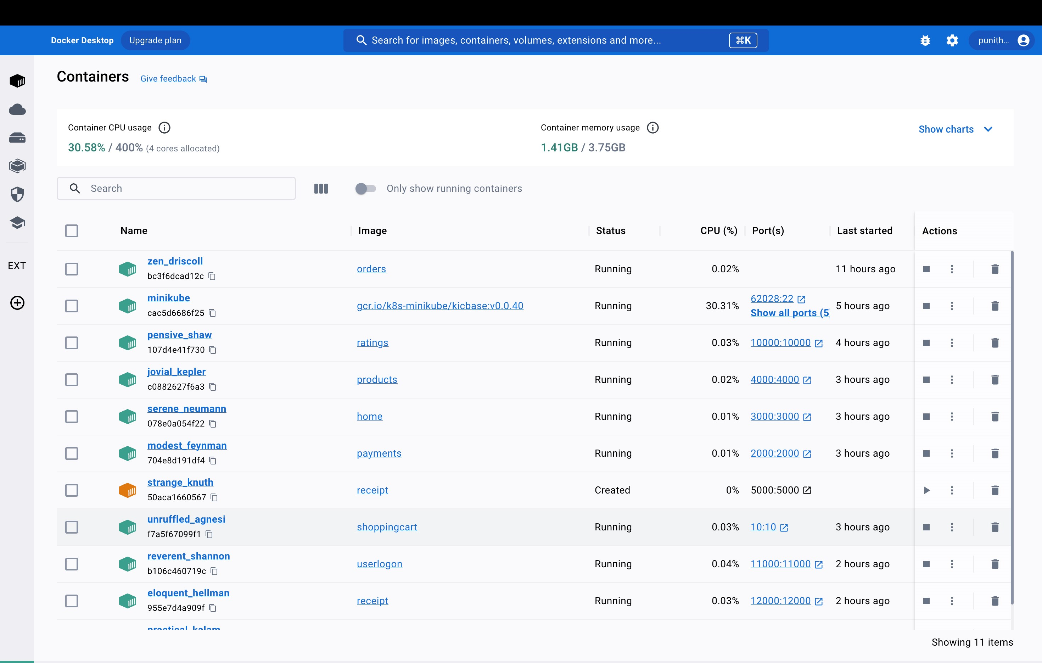

**Screenshot of Postman calling User Endpoint:**

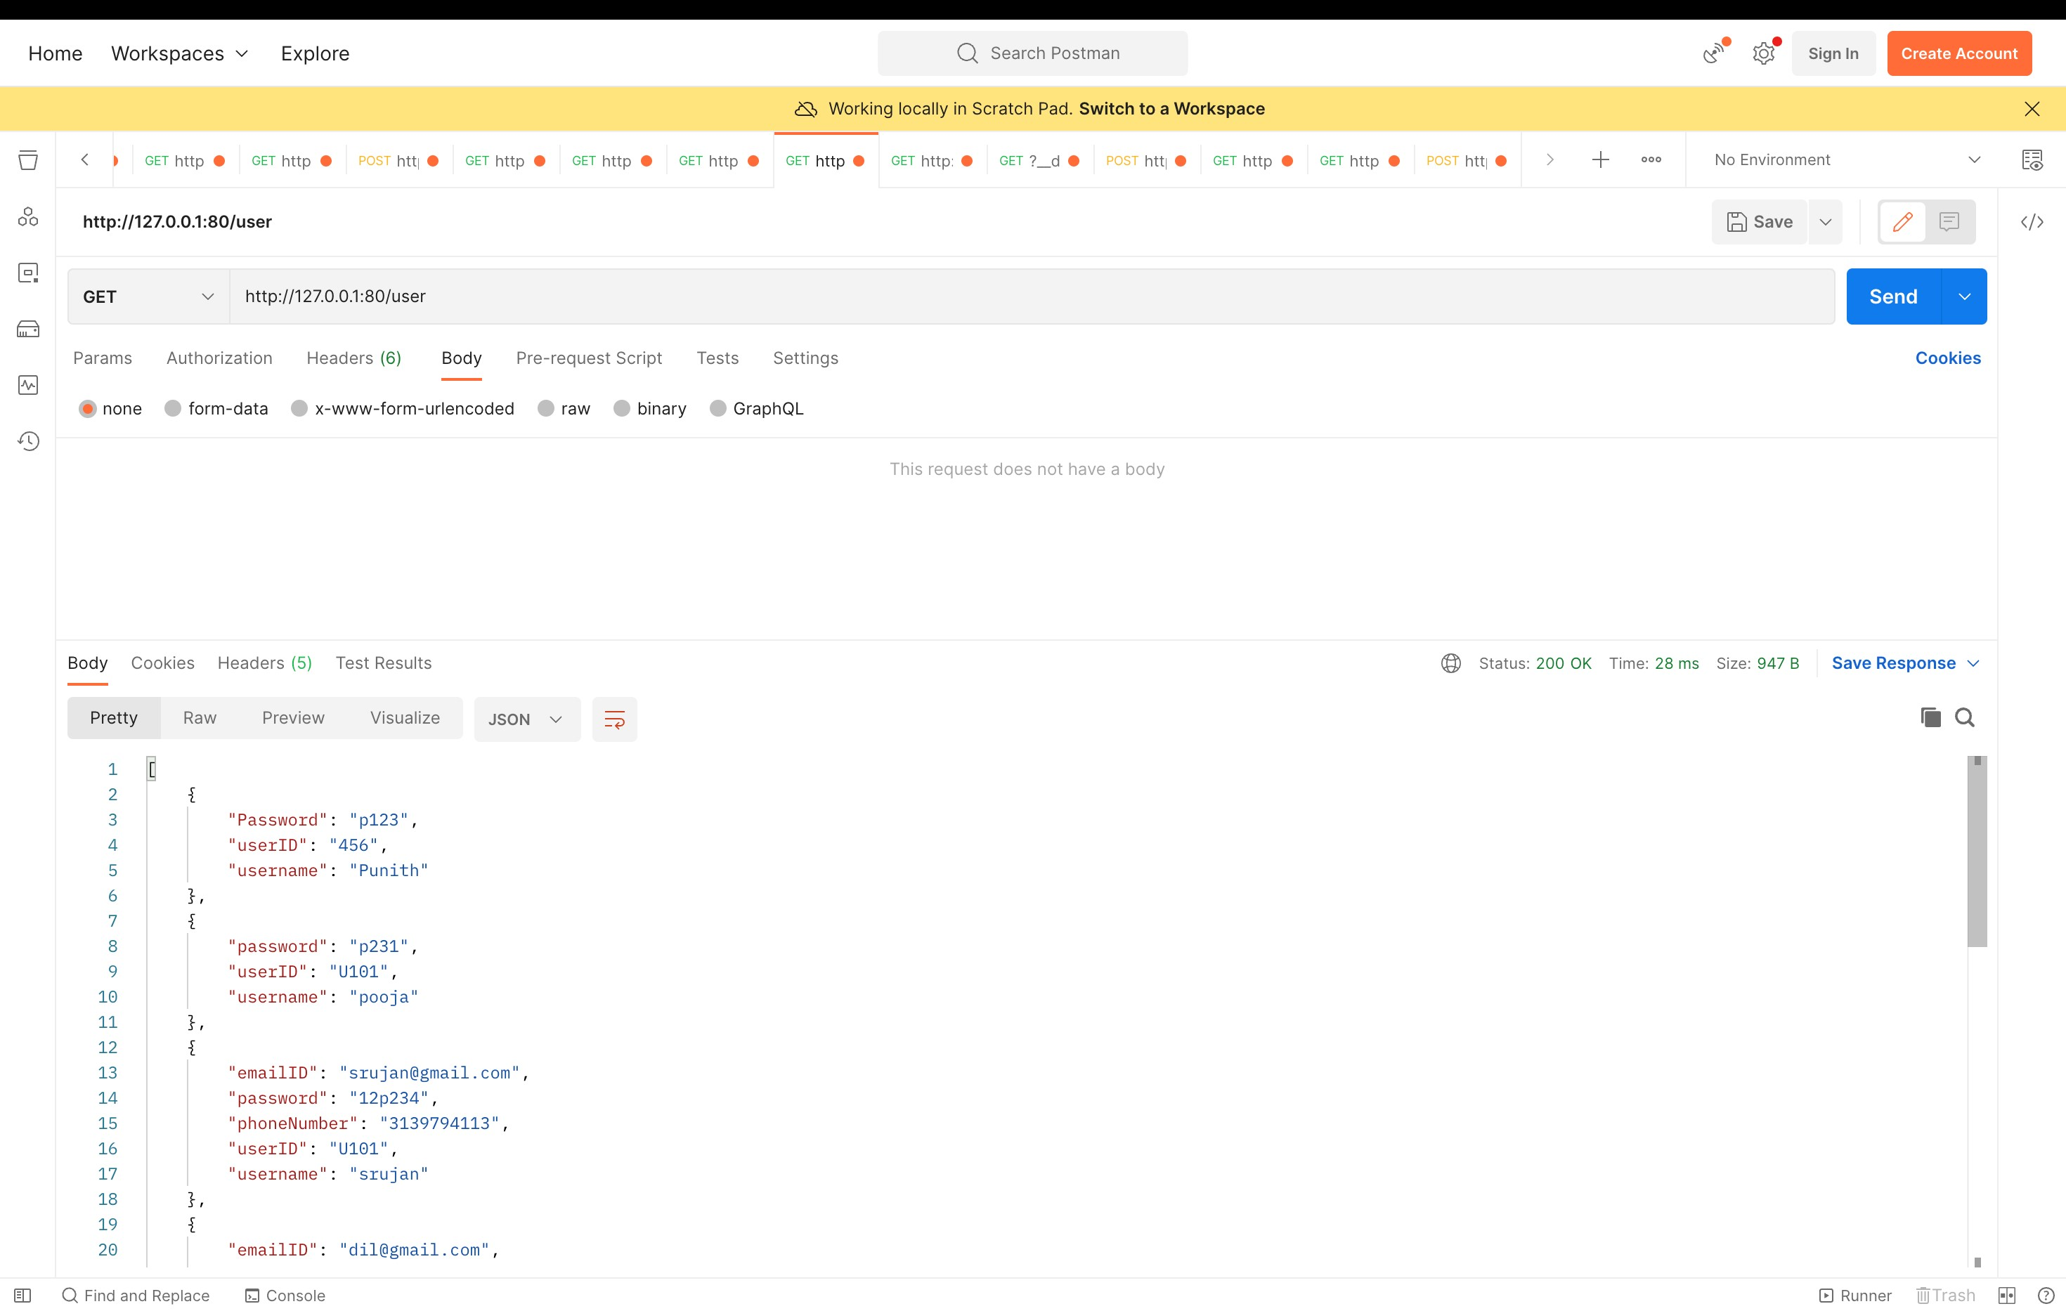

**Screenshot of Postman calling Cybersecurity Ratings Endpoint:**

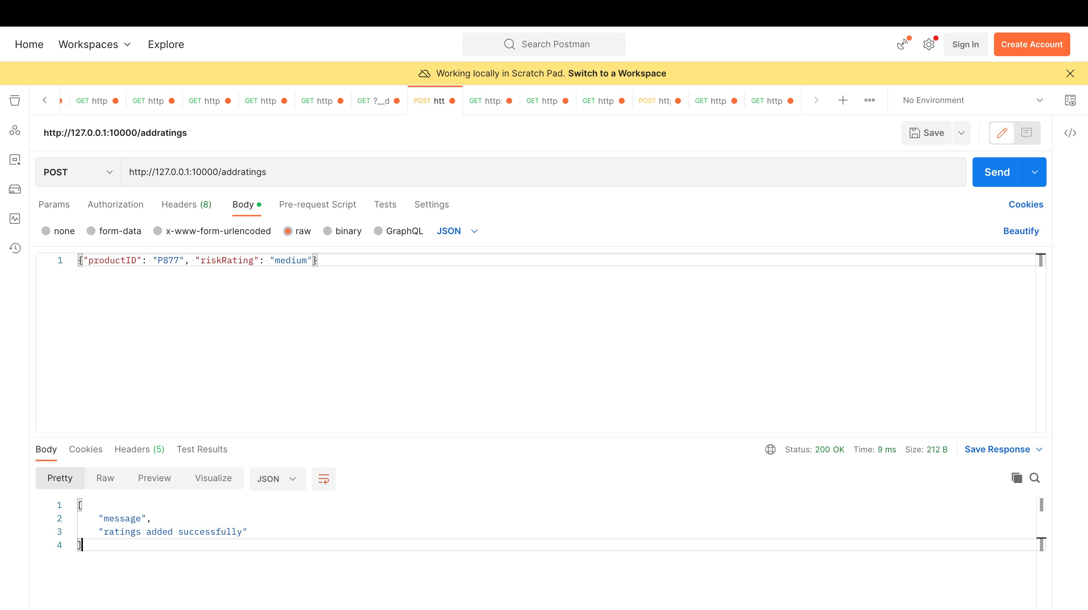

**Screenshot of Postman calling Products Endpoint:**

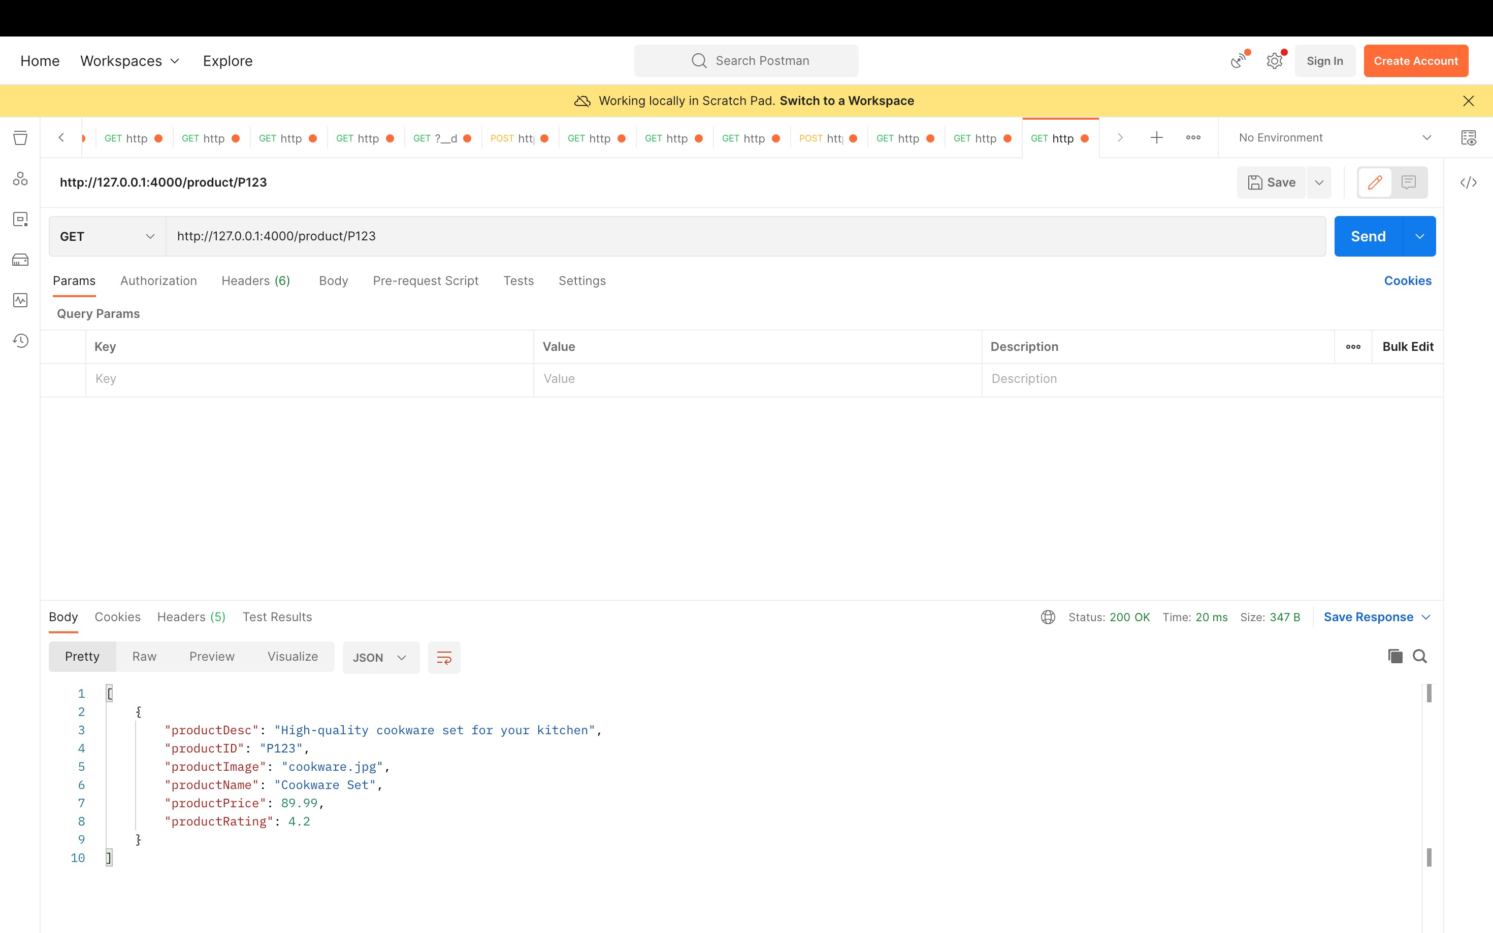

**Screenshot of Postman calling Product Receipt Endpoint:**

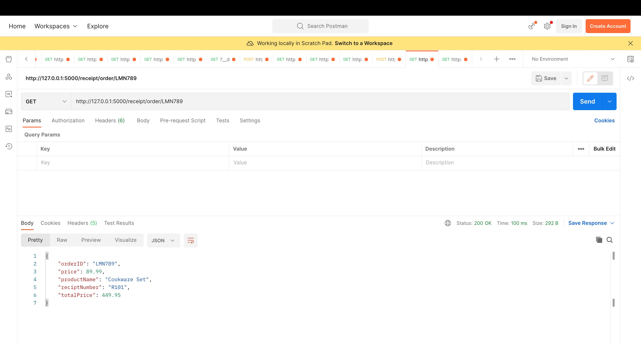

**Screenshot of Postman calling User Login Endpoint:**

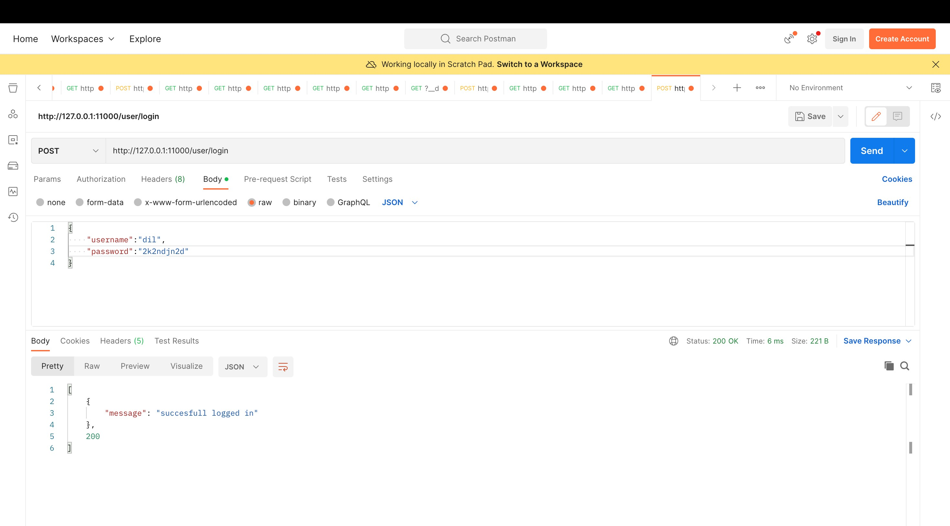

**Screenshot of Postman calling Order Details Endpoint:**

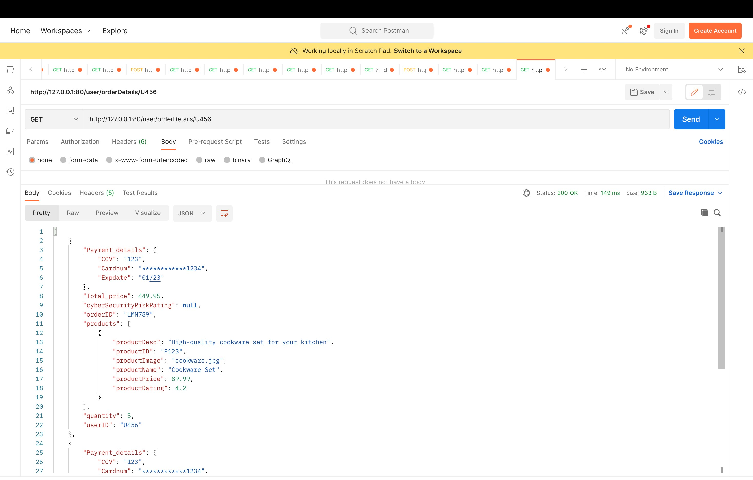

# Goals Achieved, and Remaining Goals

At the beginning of the project, just about ~2 weeks ago (seems so long), our group had set out the following goals:

1. Create an application for users to purchase a product that is risk free of vulnerabilities. - Achieved
2. Enable rapid development of proof of concept. - Achieved
3. Increase awareness of products that are severely vulnerable which pose a risk to the community. – Achieved
4. Deliver a lightweight program that is compatible with many platforms. – Achieved
5. Implement a more user-friendly interface and GUI - Remaining
6. Create a bounty program for the community to report vulnerabilities. – Remaining
7. Resolve all outstanding bugs by the project deadline. - Remaining

# Team Structure

|  |  |  |
| --- | --- | --- |
| Name | Roles | Contributions |
| Priyesh Pandya | Technical Product Manager | Responsible for Product Roadmap, features, and team. Created three microservices. Responsible for proposal creation and submission. Performed application testing. |
| Punith Agraharavalagerahalli Jayaramu | Software Architect | Responsible for Proof-of-Concept Architecture, creation of CICD pipeline and integration of microservices. Supported team members with debugging. Performed application testing. Responsible for creation of Trello. Created three microservices. |
| Hasan Ahmad | Software Engineer | Responsible for feature development. Created two microservices. Created database schema and flowchart. Performed application testing. |
| Ermin Zeherovic | Software Engineer | Responsible for feature development. Created two microservices. Performed application testing. Supported SA with integrating microservices. Responsible for creation of GitHub. |
| Jennifer Sager | Software Engineer | Responsible for feature development. Report creation and design. Performed application testing. Implemented CSS styling to improve website design language. Responsible for creation of PowerPoint and report template. |

# Tools

**GitHub**: <https://github.com/ZeherovicErmin/Emerging-Technologies>

**Trello**: <https://trello.com/b/JXWhuYPs/group-project>

**Docker Hub:**

# Conclusion